

**FACULTATEA DE ECONOMIE ȘI DE ADMINISTRARE A AFACERILOR**

**(Master – Sisteme informaționale pentru afaceri)**

**Proiect Brutăria Magda**

**Elemente de ingineria programării SIA**

**PROFESOR STUDENT**

**Prof. Univ. Dr.Mircea Gabriela Valcov Bianca**

**Timișoara**

**2021-2022**

În acest proiect se prezintă gestiunea Brutăriei Magda. Baza de date este alcatuita din 9 tabele principale(Clienti , Facturi_clienti , Vânzări , Produse, Retete, Compozitie_produse,Produse_furnizori, Furnizori,Comenzi_furnziori), care sunt relationate după cum urmează:

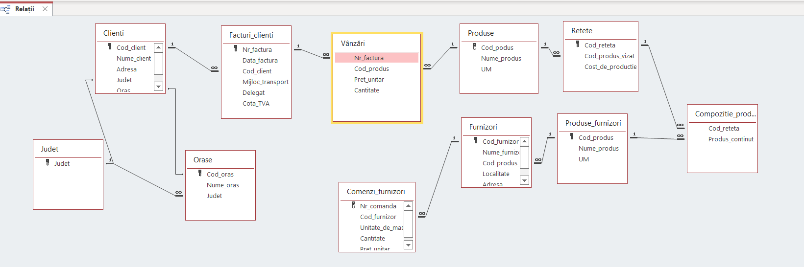

Autentificarea se face cu user si password unic la nivelul aplicatiei.

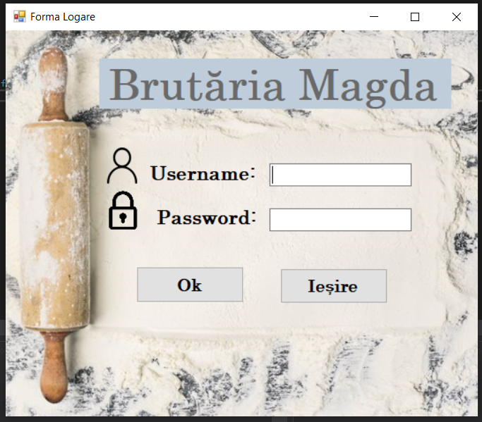

Meniul principal este alcătuit din 4 butoane care ne redirecționează la forma cu Meniu Aprovizionare, Clienți, Produse și Vânzări.

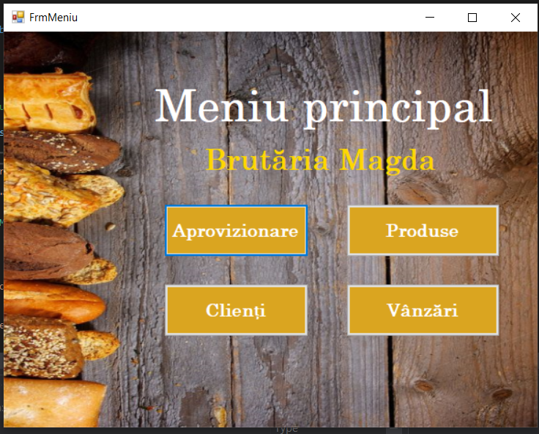

Meniul Aprovizionare contine un MenuStrip de unde putem accesa forma Furnizori, Comenzi Furnizori, Produse Furnizori și opțiunea de a ieși din meniu.

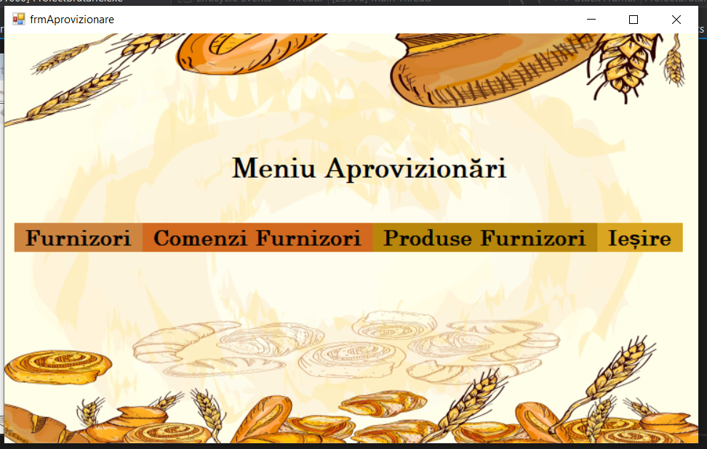

La Furnizori avem subcategoria de Adaugare Furnizor și Modificare/Ștergere Furnizori.

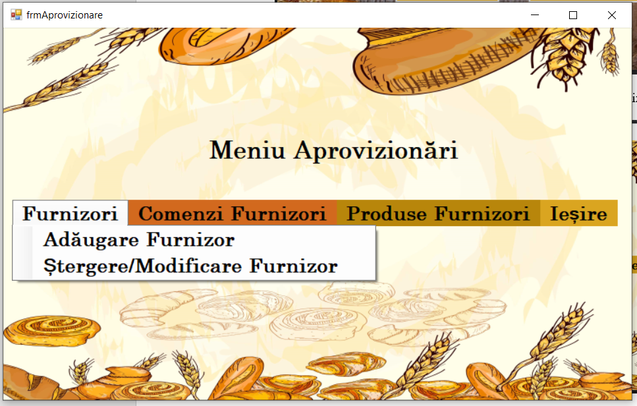

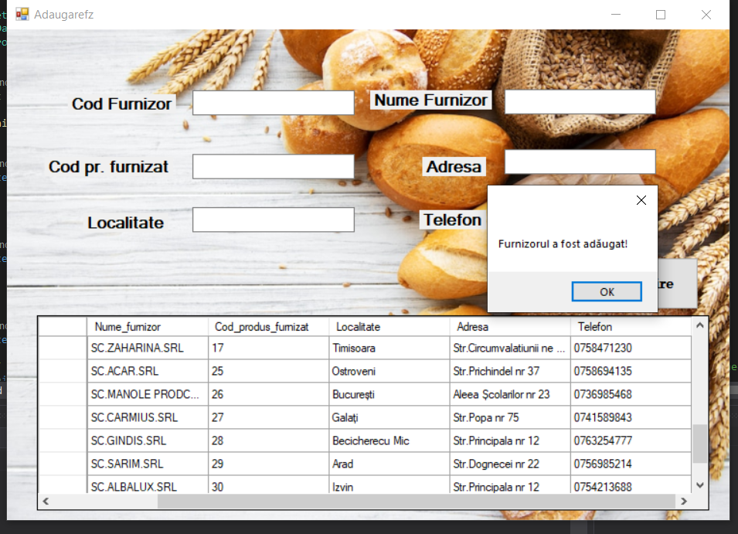

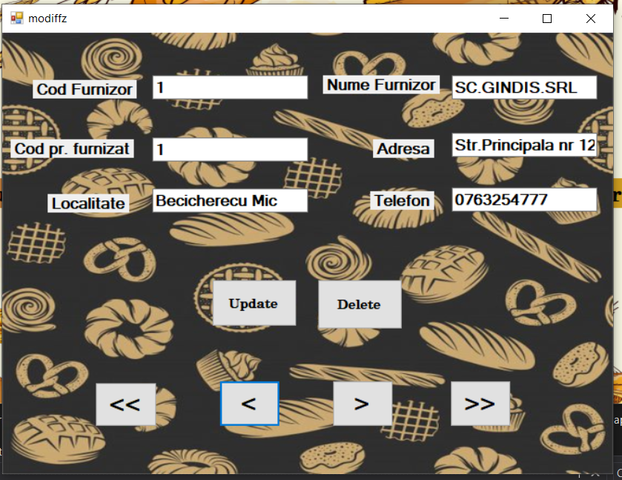

Forma Comenzi Furnizori, unde putem adăuga,anula,actualiza,șterge și salva comenzi.

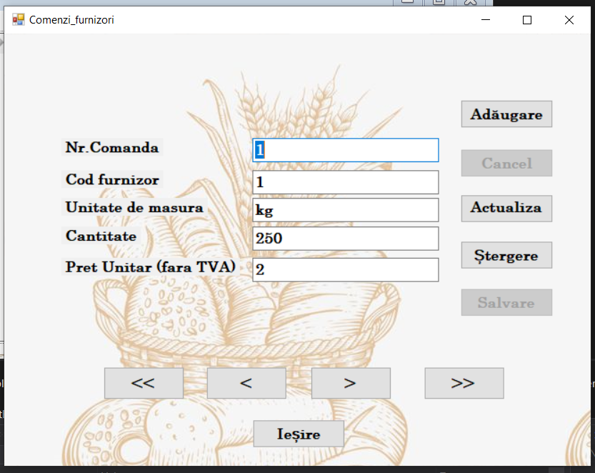

Raport al comenzilor

Formele Produse Furnizori Clienți și sunt create cu DataGridView.

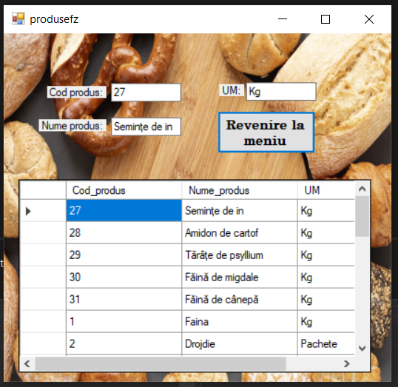

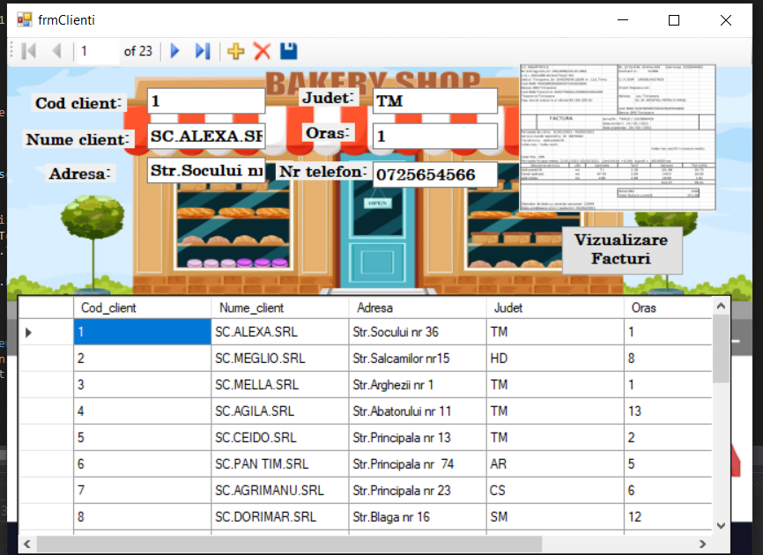

La forma Clienți avem un buton de unde putem accesa forma Facturi Clienți. Pe forma cu facturi avem un buton de unde putem viziona raportul facturilor clienților.

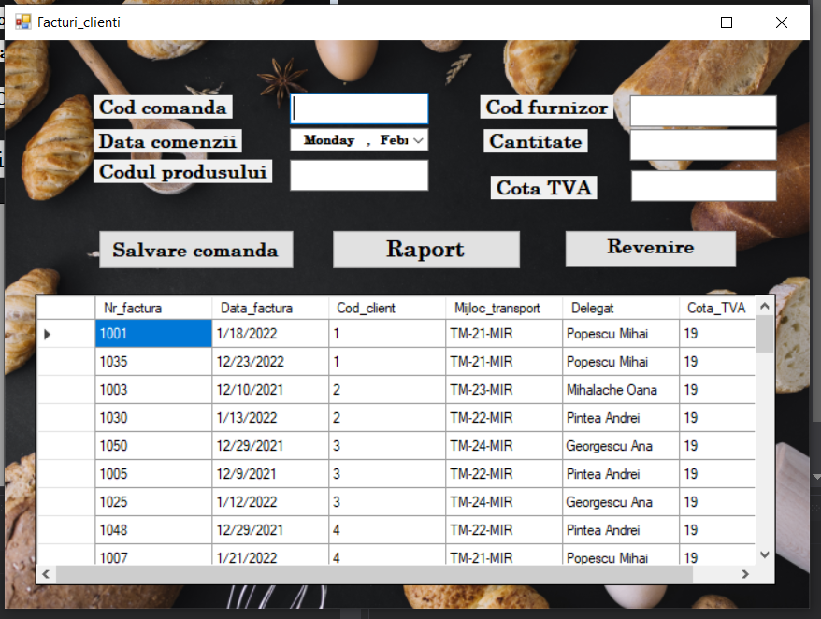

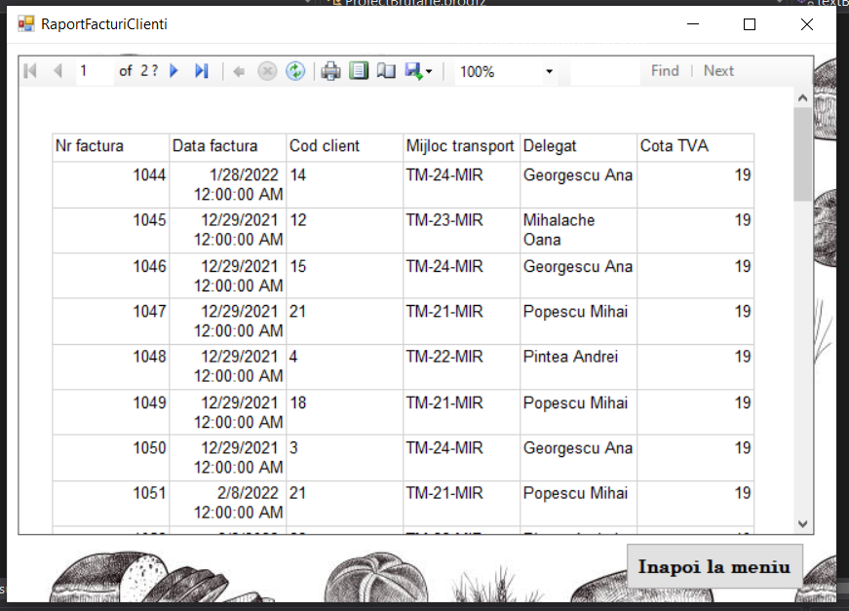

Pe forma Produse găsim un DataGridView și 3 textbox-uri de unde putem face o căutare de produs după 3 criterii.

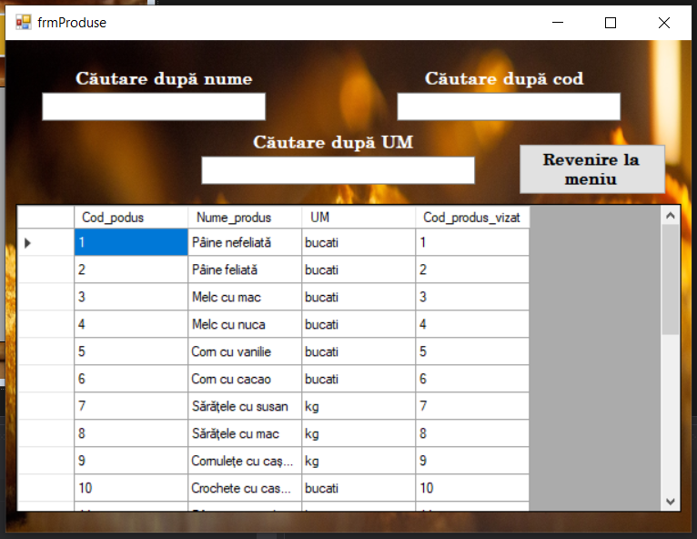

Pe forma Vânzări putem să facem căutări și actualizări de date.

**Coduri:**

**Forma frmLogin:**

using System;

using System.Collections.Generic;

using System.ComponentModel;

using System.Data;

using System.Drawing;

using System.Linq;

using System.Text;

using System.Threading.Tasks;

using System.Windows.Forms;

using System.Data.OleDb;

namespace ProiectBrutarie

{

public partial class frmLogin : Form

{

public frmLogin()

{

InitializeComponent();

}

private int j = 0; //pentru a numara cate incercari de parola s-au efectuat

private void cmdOK_Click(object sender, EventArgs e)

{

j = j + 1;

if (txtUsername.Text == "user")

{

if (txtPassword.Text == "password")

{

FrmMeniu f = new FrmMeniu();

f.Show();

this.Hide();

}

else

MessageBox.Show("Parola e incorectă!") ;

}

else

MessageBox.Show("Username-ul e incorect!");

if (j == 5) //pentru maxim trei incercari

{

MessageBox.Show("Ati avut deja 5 încercări!") ;

Application.Exit();

}

}

private void cmdIesire_Click(object sender, EventArgs e)

{

Application.Exit();

}

private void txtPassword_KeyDown(object sender, KeyEventArgs e)

{

if (e.KeyCode == Keys.Enter)

cmdOK_Click(sender, e);

}

private void label3_Click(object sender, EventArgs e)

{

}

}

}

**Forma Meniu Principal:**

using System;

using System.Collections.Generic;

using System.ComponentModel;

using System.Data;

using System.Drawing;

using System.Linq;

using System.Text;

using System.Threading.Tasks;

using System.Windows.Forms;

using System.Data.OleDb;

namespace ProiectBrutarie

{

public partial class FrmMeniu : Form

{

public static OleDbConnection con = new OleDbConnection("Provider=Microsoft.ACE.OLEDB.12.0;Data Source=|DataDirectory|\\baza_brutarie1.accdb");

public OleDbConnection conn = new OleDbConnection("Provider=Microsoft.ACE.OLEDB.12.0;Data Source=|DataDirectory|\\baza_brutarie1.accdb");

public FrmMeniu()

{

InitializeComponent();

}

private void button1_Click(object sender, EventArgs e)

{

frmAprovizionare f = new frmAprovizionare();

f.Show();

this.Hide();

}

private void button3_Click(object sender, EventArgs e)

{

frmClienti f = new frmClienti();

f.Show();

this.Hide();

}

private void button2_Click(object sender, EventArgs e)

{

frmProduse f = new frmProduse();

f.Show();

this.Hide();

}

private void button4_Click(object sender, EventArgs e)

{

frmVanzari f = new frmVanzari();

f.Show();

this.Hide();

}

private void FrmMeniu_Load(object sender, EventArgs e)

{

}

}

}

**Forma Meniu Aprovizionare:**

using System;

using System.Collections.Generic;

using System.ComponentModel;

using System.Data;

using System.Drawing;

using System.Linq;

using System.Text;

using System.Threading.Tasks;

using System.Windows.Forms;

using System.Data.OleDb;

namespace ProiectBrutarie

{

public partial class frmAprovizionare : Form

{

FrmMeniu f1 = new FrmMeniu();

public frmAprovizionare()

{

InitializeComponent();

}

private void comenziFurnizoriToolStripMenuItem_Click(object sender, EventArgs e)

{

Comenzi_furnizori f = new Comenzi_furnizori();

this.Hide();

f.Show();

}

private void produseFurnizoriToolStripMenuItem_Click(object sender, EventArgs e)

{

produsefz f = new produsefz();

this.Hide();

f.Show();

}

private void adăugareFurnizorToolStripMenuItem_Click(object sender, EventArgs e)

{

Adaugarefz f = new Adaugarefz();

f.Show();

}

private void ștergereModificareFurnizorToolStripMenuItem_Click(object sender, EventArgs e)

{

modiffz f = new modiffz();

f.Show();

}

private void ieșireToolStripMenuItem_Click(object sender, EventArgs e)

{

FrmMeniu f = new FrmMeniu();

this.Hide();

f.Show();

}

private void raportComenziToolStripMenuItem_Click(object sender, EventArgs e)

{

RaportCmzAproviz f = new RaportCmzAproviz();

this.Hide();

f.Show();

}

}

}

**Forma Adaugare Furnizori:**

using System;

using System.Collections.Generic;

using System.ComponentModel;

using System.Data;

using System.Drawing;

using System.Linq;

using System.Text;

using System.Threading.Tasks;

using System.Windows.Forms;

using System.Data.OleDb;

namespace ProiectBrutarie

{

public partial class Adaugarefz : Form

{

DataSet ds;

OleDbDataAdapter da;

public Adaugarefz()

{

InitializeComponent();

}

private void Adaugarefz_Load(object sender, EventArgs e)

{

// TODO: This line of code loads data into the 'baza_brutarie1DataSet.Furnizori' table. You can move, or remove it, as needed.

this.furnizoriTableAdapter.Fill(this.baza_brutarie1DataSet.Furnizori);

}

private void button1_Click(object sender, EventArgs e)

{

OleDbConnection con = new OleDbConnection("Provider=Microsoft.ACE.OLEDB.12.0;Data Source=|DataDirectory|\\baza_brutarie1.accdb");

string sql = "SELECT * FROM Furnizori";

ds = new DataSet();

da = new OleDbDataAdapter(sql, con);

da.Fill(ds, "Furnizori");

if (codfz.TextLength > 0)

if (denfz.TextLength > 0)

{

OleDbCommandBuilder cb = new OleDbCommandBuilder(da);

DataRow dRow = ds.Tables["Furnizori"].NewRow();

dRow[0] = codfz.Text;

dRow[1] = denfz.Text;

dRow[2] = prodfz.Text;

dRow[3] = locfz.Text;

dRow[4] = adresafz.Text;

dRow[5] = telfz.Text;

ds.Tables["Furnizori"].Rows.Add(dRow);

da.Update(ds, "Furnizori");

codfz.Text = "";

denfz.Text = "";

prodfz.Text = "";

locfz.Text = "";

adresafz.Text = "";

telfz.Text = "";

MessageBox.Show("Furnizorul a fost adăugat!");

}

else

MessageBox.Show("Toate câmpurile trebuie completate!");

}

private void button2_Click(object sender, EventArgs e)

{

Close();

}

}

}

**Forma Modificare/Ștergere Furnizori:**

using System;

using System.Collections.Generic;

using System.ComponentModel;

using System.Data;

using System.Drawing;

using System.Linq;

using System.Text;

using System.Threading.Tasks;

using System.Windows.Forms;

using System.Data.OleDb;

namespace ProiectBrutarie

{

public partial class modiffz : Form

{

DataSet dsfz;

OleDbDataAdapter dafz;

string sirSQL1;

int pozitiefz;

int nrRandurifz;

public modiffz()

{

InitializeComponent();

}

private void modiffz_Load(object sender, EventArgs e)

{

if (FrmMeniu.con.State == ConnectionState.Closed)

FrmMeniu.con.Open();

dsfz = new DataSet();

sirSQL1 = "SELECT * FROM Furnizori";

dafz = new OleDbDataAdapter(sirSQL1, FrmMeniu.con);

dafz.Fill(dsfz, "Furnizori");

nrRandurifz = dsfz.Tables["Furnizori"].Rows.Count;

pozitiefz = 0;

Navigare();

}

void Navigare()

{

DataRow dRow = dsfz.Tables["Furnizori"].Rows[pozitiefz];

codfz.Text = dRow.ItemArray.GetValue(0).ToString();

denfz.Text = dRow.ItemArray.GetValue(1).ToString();

prodfz.Text = dRow.ItemArray.GetValue(2).ToString();

locfz.Text = dRow.ItemArray.GetValue(3).ToString();

adresafz.Text = dRow.ItemArray.GetValue(4).ToString();

telfz.Text = dRow.ItemArray.GetValue(5).ToString();

}

private void button3_Click(object sender, EventArgs e)

{

DataRow dR = dsfz.Tables["Furnizori"].Rows[pozitiefz];

dR[0] = codfz.Text;

dR[1] = denfz.Text;

dR[2] = prodfz.Text;

dR[3] = locfz.Text;

dR[4] = adresafz.Text;

dR[5] = telfz.Text;

try

{

OleDbCommandBuilder cb = new OleDbCommandBuilder(dafz);

dafz.Update(dsfz, "Furnizori");

MessageBox.Show("S-au actualizat datele!");

}

catch

{

MessageBox.Show("Nu s-a putut actualiza datele!");

}

}

private void button2_Click(object sender, EventArgs e)

{

if (MessageBox.Show("Sigur doriti sa stergeti?", "Stergere", MessageBoxButtons.YesNo, MessageBoxIcon.Warning) == DialogResult.Yes)

{

dsfz.Tables["Furnizori"].Rows[pozitiefz].Delete();

OleDbCommandBuilder cb = new OleDbCommandBuilder(dafz);

dafz.Update(dsfz, "Furnizori");

nrRandurifz--;

if (pozitiefz == nrRandurifz) pozitiefz = nrRandurifz - 1;

Navigare();

MessageBox.Show("Furnizorul a fost șters!");

}

else

MessageBox.Show("Furnizorul nu a fost șters!");

}

private void button1_Click(object sender, EventArgs e)

{

if (pozitiefz != 0)

{

pozitiefz = 0;

Navigare();

}

}

private void btnPrevious_Click(object sender, EventArgs e)

{

if (pozitiefz > 0)

{

pozitiefz--;

Navigare();

}

else

MessageBox.Show("Este prima inregistrare!");

}

private void btnNext_Click(object sender, EventArgs e)

{

if (pozitiefz != nrRandurifz - 1)

{

pozitiefz++;

Navigare();

}

else

MessageBox.Show("Nu mai sunt inregistrari!");

}

private void btnLast_Click(object sender, EventArgs e)

{

if (pozitiefz != nrRandurifz - 1)

{

pozitiefz = nrRandurifz - 1;

Navigare();

}

}

}

}

**Forma Comenzi Furnizori**

using System;

using System.Collections.Generic;

using System.ComponentModel;

using System.Data;

using System.Drawing;

using System.Linq;

using System.Text;

using System.Threading.Tasks;

using System.Windows.Forms;

using System.Data.OleDb;

namespace ProiectBrutarie

{

public partial class Comenzi_furnizori : Form

{

DataSet ds;

OleDbDataAdapter da;

string sirSQL;

int pozitie;

int nrRanduri;

public Comenzi_furnizori()

{

InitializeComponent();

}

private void Comenzi_furnizori_Load(object sender, EventArgs e)

{

OleDbConnection con = new OleDbConnection("Provider=Microsoft.ACE.OLEDB.12.0;Data Source=|DataDirectory|\\baza_brutarie1.accdb");

if (con.State == ConnectionState.Closed)

con.Open();

ds = new DataSet();

sirSQL = "SELECT * FROM Comenzi_furnizori";

da = new OleDbDataAdapter(sirSQL, con);

da.Fill(ds, "Comenzi_Furnizori");

pozitie = 0;

nrRanduri = ds.Tables["Comenzi_furnizori"].Rows.Count;

btnCancel.Enabled = false;

btnSave.Enabled = false;

navigare();

}

void navigare()

{

DataRow dRow = ds.Tables["Comenzi_furnizori"].Rows[pozitie];

textBox1.Text = dRow.ItemArray.GetValue(0).ToString();

textBox2.Text = dRow.ItemArray.GetValue(1).ToString();

textBox3.Text = dRow.ItemArray.GetValue(2).ToString();

textBox4.Text = dRow.ItemArray.GetValue(3).ToString();

textBox5.Text = dRow.ItemArray.GetValue(4).ToString();

}

private void button1_Click_1(object sender, EventArgs e)

{

if (pozitie != 0)

{

pozitie = 0;

navigare();

}

}

private void button2_Click_1(object sender, EventArgs e)

{

if (pozitie > 0)

{

pozitie--;

navigare();

}

else

{

MessageBox.Show("Sunteti pe prima inregistrare!");

}

}

private void button3_Click(object sender, EventArgs e)

{

if (pozitie != nrRanduri - 1)

{

pozitie++;

navigare();

}

}

private void button4_Click(object sender, EventArgs e)

{

if (pozitie != nrRanduri - 1)

{

pozitie = nrRanduri - 1;

navigare();

}

}

private void btnAddNew_Click_1(object sender, EventArgs e)

{

OleDbConnection con = new OleDbConnection("Provider=Microsoft.ACE.OLEDB.12.0;Data Source=|DataDirectory|\\baza_brutarie1.accdb");

textBox1.Text = "";

textBox2.Clear();

textBox3.Clear();

textBox4.Clear();

textBox5.Clear();

btnAddNew.Enabled = false;

btnUpdate.Enabled = false;

btnDelete.Enabled = false;

btnSave.Enabled = true;

btnCancel.Enabled = true;

}

private void btnCancel_Click(object sender, EventArgs e)

{

btnAddNew.Enabled = true;

btnUpdate.Enabled = true;

btnDelete.Enabled = true;

btnSave.Enabled = false;

btnCancel.Enabled = false;

pozitie = 0;

navigare();

}

private void btnUpdate_Click(object sender, EventArgs e)

{

OleDbConnection con = new OleDbConnection("Provider=Microsoft.ACE.OLEDB.12.0;Data Source=|DataDirectory|\\baza_brutarie1.accdb");

DataRow dR = ds.Tables["Comenzi_furnizori"].Rows[pozitie];

dR[0] = textBox1.Text;

dR[1] = textBox2.Text;

dR[2] = textBox3.Text;

dR[3] = textBox4.Text;

dR[4] = textBox5.Text;

try

{

OleDbCommandBuilder cb = new OleDbCommandBuilder(da);

da.Update(ds, "Comenzi_furnizori");

MessageBox.Show("S-au actualizat datele!");

}

catch

{

MessageBox.Show("Datele nu s-au putut actualiza!");

}

}

private void btnDelete_Click(object sender, EventArgs e)

{

if (MessageBox.Show("Sigur doriti sa stergeti inregistrarea?", "Stergere", MessageBoxButtons.YesNo, MessageBoxIcon.Warning) == DialogResult.Yes)

{

ds.Tables["Comenzi_furnizori"].Rows[pozitie].Delete();

OleDbCommandBuilder cb = new OleDbCommandBuilder(da);

da.Update(ds, "Comenzi_furnizori");

nrRanduri--;

if (pozitie == nrRanduri)

pozitie = nrRanduri - 1;

navigare();

MessageBox.Show("S-a sters inregistrarea!");

}

else

MessageBox.Show("Nu s-a sters inregistrarea");

}

private void btnSave_Click(object sender, EventArgs e)

{

OleDbConnection con = new OleDbConnection("Provider=Microsoft.ACE.OLEDB.12.0;Data Source=|DataDirectory|\\baza_brutarie1.accdb");

DataRow dRow;

dRow = ds.Tables["Comenzi_furnizori"].NewRow();

dRow["Nr_comanda"] = textBox1.Text;

dRow["Cod_furnizor"] = textBox2.Text;

dRow["Unitate_de_masura"] = textBox3.Text;

dRow["Cantitate"] = textBox4.Text;

dRow["Pret_unitar"] = textBox5.Text;

ds.Tables["Comenzi_furnizori"].Rows.Add(dRow);

try

{

OleDbCommandBuilder cb = new OleDbCommandBuilder(da);

da.Update(ds, "Comenzi_furnizori");

MessageBox.Show("S-a salvat noua comandă!");

nrRanduri++;

pozitie = nrRanduri - 1;

btnAddNew.Enabled = true;

btnUpdate.Enabled = true;

btnDelete.Enabled = true;

btnSave.Enabled = false;

btnCancel.Enabled = false;

}

catch

{

MessageBox.Show("Nu s-a putut realiza salvarea");

}

}

private void button5_Click(object sender, EventArgs e)

{

frmAprovizionare f = new frmAprovizionare();

this.Hide();

f.Show();

}

}

}

**Forma Clienți:**

using System;

using System.Collections.Generic;

using System.ComponentModel;

using System.Data;

using System.Drawing;

using System.Linq;

using System.Text;

using System.Threading.Tasks;

using System.Windows.Forms;

namespace ProiectBrutarie

{

public partial class frmClienti : Form

{

public frmClienti()

{

InitializeComponent();

}

private void clientiBindingNavigatorSaveItem_Click(object sender, EventArgs e)

{

this.Validate();

this.clientiBindingSource.EndEdit();

this.tableAdapterManager.UpdateAll(this.baza_brutarie1DataSet);

}

private void frmClienti_Load(object sender, EventArgs e)

{

// TODO: This line of code loads data into the 'baza_brutarie1DataSet.Clienti' table. You can move, or remove it, as needed.

this.clientiTableAdapter.Fill(this.baza_brutarie1DataSet.Clienti);

}

private void button2_Click(object sender, EventArgs e)

{

Facturi_clienti f = new Facturi_clienti();

this.Hide();

f.Show();

}

}

}

**Forma Facturi Clienti:**

using System;

using System.Collections.Generic;

using System.ComponentModel;

using System.Data;

using System.Drawing;

using System.Linq;

using System.Text;

using System.Threading.Tasks;

using System.Windows.Forms;

using System.Data.OleDb;

namespace ProiectBrutarie

{

public partial class Facturi_clienti : Form

{

DataSet ds;

OleDbDataAdapter da;

FrmMeniu conn = new FrmMeniu(); //var de tipul formei 1

public Facturi_clienti()

{

InitializeComponent();

}

private void button1_Click(object sender, EventArgs e)

{

if (FrmMeniu.con != null && FrmMeniu.con.State == ConnectionState.Closed)

FrmMeniu.con.Open();

try

{

OleDbCommand cmd2 = new OleDbCommand();

cmd2.Connection = FrmMeniu.con;

cmd2.CommandText = @"Insert into Facturi_clienti (Nr_factura, Data_factura, Cod_client, Mijloc_transport, Delegat, Cota_TVA) values (@Nr_factura, @Data_factura, @Cod_client, @Mijloc_transport, @Delegat, @Cota_TVA)";

cmd2.Parameters.AddWithValue("@Nr_factura", txt_codcomanda.Text);

cmd2.Parameters.AddWithValue("@Data_factura", dateTimePicker1.Text);

cmd2.Parameters.AddWithValue("@Cod_client", txt_cantitate.Text);

cmd2.Parameters.AddWithValue("@Mijloc_transport", txt_codprodus.Text);

cmd2.Parameters.AddWithValue("@Delegat", txt_codfurnizor.Text);

cmd2.Parameters.AddWithValue("@Cota_TVA", txtCota.Text);

cmd2.ExecuteNonQuery();

MessageBox.Show("Comanda inregistrata");

//facem try pt ca codcom e pk si daca introducem de 2 ori aceeasi valoare=>eroare

}

catch

{

MessageBox.Show("EROARE: Comanda deja existenta");

}

}

private void button2_Click(object sender, EventArgs e)

{

FrmMeniu f = new FrmMeniu();

this.Hide();

f.Show();

}

private void Facturi_clienti_Load(object sender, EventArgs e)

{

string sql = @"select Facturi_clienti.Nr_factura, Facturi_clienti.Data_factura, Clienti.Cod_client, Facturi_clienti.Mijloc_transport, Delegat, Cota_TVA from Facturi_clienti, Clienti where Facturi_clienti.Cod_client=Clienti.Cod_client";

da = new OleDbDataAdapter(sql, FrmMeniu.con); //var noastra si con pt ca se afla in f1

ds = new DataSet();

da.Fill(ds, "Facturi_clienti");

dataGridView1.DataSource = ds.Tables["Facturi_clienti"];

}

private void button3_Click(object sender, EventArgs e)

{

RaportFacturiClienti f = new RaportFacturiClienti();

this.Hide();

f.Show();

}

}

}

using System;

using System.Collections.Generic;

using System.ComponentModel;

using System.Data;

using System.Drawing;

using System.Linq;

using System.Text;

using System.Threading.Tasks;

using System.Windows.Forms;

using System.Data.OleDb;

namespace ProiectBrutarie

{

public partial class frmProduse : Form

{

DataSet ds;

OleDbDataAdapter da;

FrmMeniu f = new FrmMeniu();

public frmProduse()

{

InitializeComponent();

}

private void frmProduse_Load(object sender, EventArgs e)

{

OleDbConnection con = new OleDbConnection("Provider=Microsoft.ACE.OLEDB.12.0;Data Source=|DataDirectory|\\baza_brutarie1.accdb");

string sql = @"select Produse.Cod_podus, Produse.Nume_produs, UM, Retete.Cod_produs_vizat from Produse, Retete where Produse.Cod_podus=Retete.Cod_produs_vizat";

da = new OleDbDataAdapter(sql, con);

ds = new DataSet();

da.Fill(ds, "Produse");

dataGridView1.DataSource = ds.Tables["Produse"];

}

private void cauta()

{

OleDbCommand query = new OleDbCommand(@"SELECT Produse.Cod_podus, Produse.Nume_produs, UM, Retete.Cod_produs_vizat from Produse, Retete where Produse.Cod_podus=Retete.Cod_produs_vizat And Produse.Nume_produs Like @denpr And Retete.Cod_produs_vizat LIKE @denfz And Produse.UM LIKE @um", FrmMeniu.con);

query.Parameters.AddWithValue("@denpr", "%" + txtdenprod.Text + "%");

query.Parameters.AddWithValue("@denfz", "%" + txtdenfz.Text + "%");

query.Parameters.AddWithValue("@um", "%" + um.Text + "%");

da = new OleDbDataAdapter(query);

ds = new DataSet();

da.Fill(ds, "Produse");

dataGridView1.DataSource = ds.Tables["Produse"];

}

private void txtdenprod_TextChanged(object sender, EventArgs e)

{

cauta();

}

private void txtdenfz_TextChanged(object sender, EventArgs e)

{

cauta();

}

private void button1_Click(object sender, EventArgs e)

{

FrmMeniu f = new FrmMeniu();

this.Hide();

f.Show();

}

private void um_TextChanged(object sender, EventArgs e)

{

cauta();

}

}

}

**Forma Produse:**

using System;

using System.Collections.Generic;

using System.ComponentModel;

using System.Data;

using System.Drawing;

using System.Linq;

using System.Text;

using System.Threading.Tasks;

using System.Windows.Forms;

using System.Data.OleDb;

namespace ProiectBrutarie

{

public partial class frmProduse : Form

{

DataSet ds;

OleDbDataAdapter da;

FrmMeniu f = new FrmMeniu();

public frmProduse()

{

InitializeComponent();

}

private void frmProduse_Load(object sender, EventArgs e)

{

OleDbConnection con = new OleDbConnection("Provider=Microsoft.ACE.OLEDB.12.0;Data Source=|DataDirectory|\\baza_brutarie1.accdb");

string sql = @"select Produse.Cod_podus, Produse.Nume_produs, UM, Retete.Cod_produs_vizat from Produse, Retete where Produse.Cod_podus=Retete.Cod_produs_vizat";

da = new OleDbDataAdapter(sql, con);

ds = new DataSet();

da.Fill(ds, "Produse");

dataGridView1.DataSource = ds.Tables["Produse"];

}

private void cauta()

{

OleDbCommand query = new OleDbCommand(@"SELECT Produse.Cod_podus, Produse.Nume_produs, UM, Retete.Cod_produs_vizat from Produse, Retete where Produse.Cod_podus=Retete.Cod_produs_vizat And Produse.Nume_produs Like @denpr And Retete.Cod_produs_vizat LIKE @denfz And Produse.UM LIKE @um", FrmMeniu.con);

query.Parameters.AddWithValue("@denpr", "%" + txtdenprod.Text + "%");

query.Parameters.AddWithValue("@denfz", "%" + txtdenfz.Text + "%");

query.Parameters.AddWithValue("@um", "%" + um.Text + "%");

da = new OleDbDataAdapter(query);

ds = new DataSet();

da.Fill(ds, "Produse");

dataGridView1.DataSource = ds.Tables["Produse"];

}

private void txtdenprod_TextChanged(object sender, EventArgs e)

{

cauta();

}

private void txtdenfz_TextChanged(object sender, EventArgs e)

{

cauta();

}

private void button1_Click(object sender, EventArgs e)

{

FrmMeniu f = new FrmMeniu();

this.Hide();

f.Show();

}

private void um_TextChanged(object sender, EventArgs e)

{

cauta();

}

}

}

**Forma Vânzări:**

using System;

using System.Collections.Generic;

using System.ComponentModel;

using System.Data;

using System.Drawing;

using System.Linq;

using System.Text;

using System.Threading.Tasks;

using System.Windows.Forms;

using System.Data.OleDb;

namespace ProiectBrutarie

{

public partial class frmVanzari : Form

{

DataSet ds;

OleDbDataAdapter da;

FrmMeniu f1 = new FrmMeniu();

public frmVanzari()

{

InitializeComponent();

}

private void btnCauta_Click(object sender, EventArgs e)

{

OleDbCommand sql = new OleDbCommand("SELECT * FROM Vânzări", FrmMeniu.con);

if (textBox1.Text != "")

{

sql.CommandText += " WHERE Cod_produs LIKE @Cod_produs ";

sql.Parameters.AddWithValue("@Cod_produs", "%" + textBox1.Text + "%");

}

da = new OleDbDataAdapter(sql);

// cod comun in cazul ambelor variante

ds = new DataSet();

da.Fill(ds, "Vânzări");

dataGridView1.DataSource = ds.Tables["Vânzări"];

}

private void button1_Click(object sender, EventArgs e)

{

Close();

FrmMeniu f = new FrmMeniu();

this.Hide();

f.Show();

}

private void textBox1_TextChanged(object sender, EventArgs e)

{

btnCauta_Click(sender, e);

}

private void btnSalvare_Click(object sender, EventArgs e)

{

string sirSqlUpdate = "UPDATE Vânzări SET Cod_produs = @Cod_produs WHERE Nr_factura = @Nr_factura";

OleDbCommand comandaUpdate = new OleDbCommand(sirSqlUpdate, FrmMeniu.con);

// Comenzile Parameters.Add de mai jos adauga un parametru specificand

// numele parametrului (de ex. @den_categ), tipul de data, lung. campului si numele campului

comandaUpdate.Parameters.Add("@Cod_produs", OleDbType.VarChar, 50, "Cod_produs");

comandaUpdate.Parameters.Add("@Nr_factura", OleDbType.Integer, 4, "Nr_factura");

string sirSqlInsert = "INSERT INTO Vânzări (Cod_produs) VALUES (@Cod_produs)";

OleDbCommand comandaInsert = new OleDbCommand(sirSqlInsert, FrmMeniu.con);

comandaInsert.Parameters.Add("@Cod_produs", OleDbType.VarChar, 50, "Cod_produs");

string sirSqlDelete = "DELETE FROM Vânzări WHERE Nr_factura = @Nr_factura";

OleDbCommand comandaDelete = new OleDbCommand(sirSqlDelete, FrmMeniu.con);

comandaDelete.Parameters.Add("@Nr_factura", OleDbType.Integer, 4, "Nr_factura");

da.InsertCommand = comandaInsert;

da.UpdateCommand = comandaUpdate;

da.DeleteCommand = comandaDelete;

da.Update(ds, "Vânzări");

MessageBox.Show("Tabela a fost actualizată");

}

}

}